**Form Setoran Hafalan Juz 30**

Muhammad Ramdan – 1904637 – TE02 2019

|  |  |  |
| --- | --- | --- |
| No. | Surat | Hafal (Ya/ Tidak) |
| 1 | An-Nas | Ya |
| 2 | Al-Falaq | Ya |
| 3 | Al-Ikhlas | Ya |
| 4 | Al-Lahab | Ya |
| 5 | An-Nasr | Ya |
| 6 | Al-Kafirun | Ya |
| 7 | Al-Kautsar | Ya |
| 8 | Al-Ma’un | Ya |
| 9 | Quraisy | Ya |
| 10 | Al-Fil | Ya |
| 11 | Al-Humazah | Ya |
| 12 | Al-‘Asr | Ya |
| 13 | At-Takastur | Ya |
| 14 | Al-Qari’ah | Ya |
| 15 | Al-‘Adiyat | Ya |
| 16 | Az-Zalzalah | Ya |
| 17 | Al-Bayyinah | Ya |
| 18 | Al-Qadr | Ya |
| 19 | Al-‘Alaq | Ya |
| 20 | At-Tin | Ya |
| 21 | Al-Insyirah | Ya |
| 22 | Ad-Dhuha | Ya |
| 23 | Al-Lail | Ya |
| 24 | Asy-Syams | Ya |
| 25 | Al-Balad | Ya |
| 26 | Al-Fajr | Ya |
| 27 | Al-Ghasyiyah | Ya |
| 28 | Al-A’la | Ya |
| 29 | At-Tariq | Ya |
| 30 | Al-Buruj | Ya |
| 31 | Al-Insyiqaq | Ya |
| 32 | Al-Mutaffifin | Ya |
| 33 | Al-Infitar | Ya |
| 34 | At-Takwir | Ya |
| 35 | ‘Abasa | Ya |
| 36 | An-Naziat | Ya |
| 37 | An-Naba | Ya |

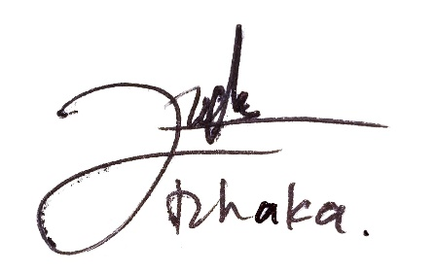

Bandung, 28 Desember 2021. Penerima setoran